Johnny A. Rojas & Aiden Sitorus, George Nicacio, Jeremiah Hasibuan, Matthew Miller
A LAB REPORT ON THE RC TIME CONSTANT

Theory
An electrical circuit consisting of a resistor and a capacitor—commonly referred to as an RC circuit—exhibits a fundamentally different behavior from a purely resistive circuit. At the heart of this difference is the capacitor’s ability to store charge on its plates. For a capacitor subjected to an electric potential difference $V$, the relationship between the stored charge $Q$ and the voltage is given by:
$$\begin{matrix}Q\text{=}CV\end{matrix}$$
where $C$ is the capacitance, a property of the capacitor that quantifies how much charge it can store per unit voltage. What makes RC circuits particularly interesting is not just the fact that charge accumulates, but how it accumulates over time.
When a switch is closed and the capacitor begins to charge, the rate at which charge builds up on the plates is not constant—it slows down as the voltage across the capacitor approaches that of the power supply. This behavior is characteristic of an exponential function, a special class of function whose rate of change is proportional to its current value. In other words, the more charge the capacitor has already accumulated, the slower it continues to charge. This same logic applies in reverse during discharging: the more charge remains, the faster it leaves, and the process slows as the plates approach neutrality.
To see where this exponential form comes from, we can apply Kirchhoff’s voltage law to the RC circuit during charging. The voltage supplied by the source $E$ must equal the sum of the voltage drops across the resistor and the capacitor:
$$\begin{matrix}E\text{=}V_{R}\text{+}V_{C}\text{=}IR\text{+}\frac{Q}{C}\end{matrix}$$
Since the current is the rate of change of charge, $I\text{=}dQ\text{/}dt$, we can substitute directly into the equation above to obtain the following first-order differential equation:
$$\begin{matrix}E\text{=}R\frac{dQ}{dt}\text{+}\frac{Q}{C}\end{matrix}$$
Rearranging to isolate the derivative:
$$\begin{matrix}\frac{dQ}{dt}\text{=}\frac{E}{R}−\frac{Q}{RC}\end{matrix}$$
This equation tells us that the rate at which charge accumulates on the capacitor decreases as $Q$ grows—precisely the behavior we described as exponential. Solving this differential equation with the initial condition $Q(0)\text{=}0$, and converting back to voltage using $V_{C}\text{=}Q\text{/}C$, yields the solution for the voltage across the capacitor during charging:
$$\begin{matrix}V_{C}(t)\text{=}E\left(1−e^{−t\text{/}τ}\right)\end{matrix}$$
and during discharging from an initial voltage $V_{0}$:
$$\begin{matrix}V_{C}(t)\text{=}V_{0}e^{−t\text{/}τ}\end{matrix}$$
In both expressions, $τ$ is the RC time constant, defined as:
$$\begin{matrix}τ\text{=}RC\end{matrix}$$
The time constant $τ$ carries units of seconds and has a concrete physical meaning: it is the time it takes for the capacitor to charge to approximately $63.2\text{\%}$ of the supply voltage, or to discharge to approximately $36.8\text{\%}$ of its initial voltage—values that follow directly from evaluating $e^{−1}$.
The goal of this experiment is to verify this theoretical prediction experimentally using an RC circuit built on a breadboard with a known resistance $R\text{=}3,300Ω$ and capacitance $C\text{=}470μ\text{F}$, giving a theoretical time constant of:
$$\begin{matrix}τ_{\text{theory}}\text{=}RC\text{=}(3,300)(470×{10}^{−6})≈1.551\text{s}\end{matrix}$$
Rather than measuring charge or current directly, we record the voltage across the capacitor over time using the PASCO 850 interface and voltage sensor, as voltage is the most directly accessible quantity given our available instrumentation.

Conclusion

Activity 1: Charging a Capacitor
To evaluate the charging behavior of the capacitor, the voltage data collected from the PASCO sensor was fitted to an exponential trendline in Excel. Since the charging equation takes the form $V_{C}(t)\text{=}E(1−e^{−t\text{/}τ})$, the coefficient $−1\text{/}RC$ was used as the key quantity to compare between theory and experiment, as it can be extracted directly from the exponential trendline fit. The theoretical and experimental values are summarized below:
Quantity | Theoretical | Experimental
$−1\text{/}RC$ (s${}^{−1}$) | $$−0.644745$$ | $$−0.514350$$
Percent Error | $$20.22\text{\%}$$
$$R^{2}$$ | $$0.99829$$
The $R^{2}$ value of $0.99829$ and a percent error of $20.22\text{\%}$, well within our acceptable threshold of $25\text{\%}$, confirm that the theoretical model successfully predicts the exponential charging behavior of the capacitor. The voltage across the capacitor rises in a manner consistent with the form prescribed by theory, validating the RC model for this activity.

Activity 2: Discharging a Capacitor
For the discharging phase, the capacitor was allowed to charge fully before the power supply was switched off, and the subsequent voltage decay was recorded and fitted in the same manner. The discharge follows $V_{C}(t)\text{=}V_{0}e^{−t\text{/}τ}$, and the results are summarized below:
Quantity | Theoretical | Experimental
$−1\text{/}RC$ (s${}^{−1}$) | $$−0.644745$$ | $$−0.564400$$
Percent Error | $$14.23\text{\%}$$
$$R^{2}$$ | $$0.99974$$
The $R^{2}$ value of $0.99974$ and a percent error of $14.23\text{\%}$ confirm once again that the theoretical model successfully predicts the exponential discharging behavior of the capacitor. The voltage decays in a manner fully consistent with the theoretical form, further validating the RC model for this activity.

Overall Conclusion
Across both activities, the RC model proves to be a reliable predictor of the voltage behavior of a capacitor, with both percent errors falling well within the $25\text{\%}$ acceptable threshold and $R^{2}$ values approaching unity. However, a notable observation emerges when comparing the two experimentally obtained values of $−1\text{/}RC$: the charging activity yielded $−0.514350$ s${}^{−1}$, while the discharging activity yielded $−0.564400$ s${}^{−1}$. These two values are not equal, despite the fact that the same physical components were used in both cases. This discrepancy points to a real limitation of the setup—during charging, the PASCO 850 power supply is active in the circuit and its internal resistance adds to the total resistance experienced by the capacitor, effectively slowing the charging rate and pushing the experimental $−1\text{/}RC$ further from the theoretical value. During discharging, the power supply is disconnected, and so its internal resistance no longer participates, allowing the capacitor to discharge more closely to the ideal prediction.
To address this limitation in future experiments, we propose computing the theoretical $RC$ using the actual voltage the capacitor experiences at the onset of each phase, rather than relying on the nominal component values alone. This approach would decouple the charging and discharging dynamics from the influence of the power supply, producing a theoretical prediction that is tailored to each activity independently and therefore more physically meaningful.

Questions

Activity 1: Graphs
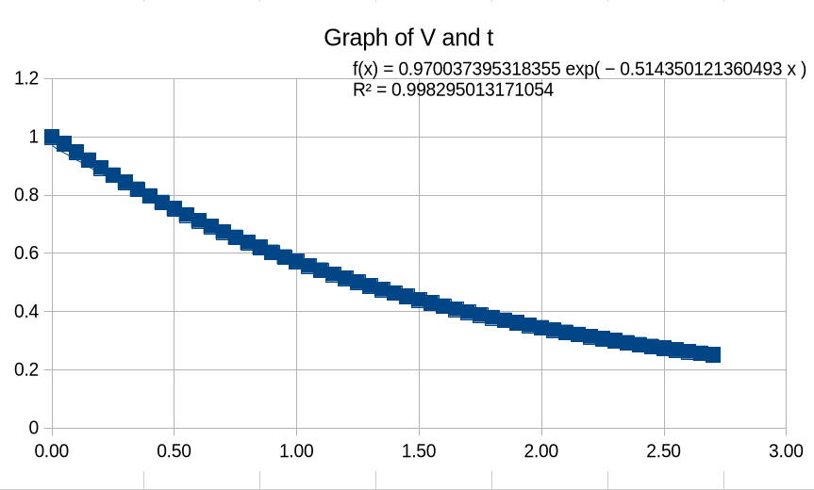
Voltage vs. Time for the Charging of the Capacitor (Activity 1)

Activity 2: Graphs
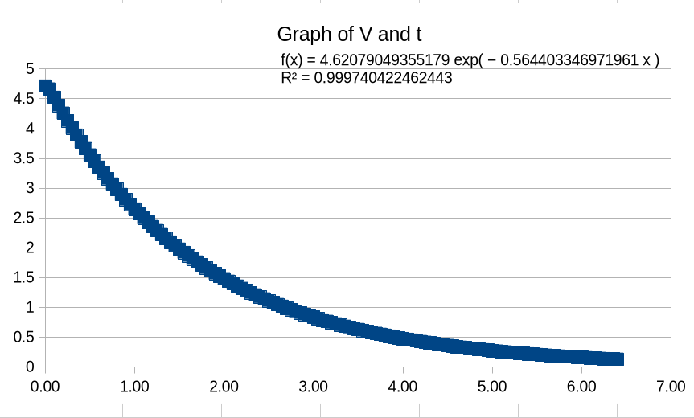
Voltage vs. Time for the Discharging of the Capacitor (Activity 2)

Above and Beyond
One of the most quietly profound observations of this experiment is not found in the data itself, but in the tool we used to describe it. The exponential function, a construct born purely from the rules of calculus and the study of self-referential rates of change, turns out to describe with remarkable precision the physical behavior of electrons accumulating on a capacitor plate. This is not obvious. There is no immediate reason why the abstract solution to a differential equation should map so cleanly onto the behavior of a circuit sitting on a breadboard. And yet it does.
This alignment between mathematics and physical reality has puzzled philosophers for centuries. When negative numbers were first introduced, they were met with deep skepticism—the idea of a quantity less than nothing seemed to have no grounding in the real world, a purely symbolic trick with no physical referent. Imaginary numbers faced an even steeper resistance: Gerolamo Cardano, who first made use of them in the 16th century, described them as “fictitious” and “useless.” And yet imaginary numbers today are indispensable in the very field this experiment touches—AC circuit analysis, quantum mechanics, and signal processing all rest on a foundation built from $\sqrt{−1}$. Linear algebra, once regarded as an abstract exercise in manipulating arrays of numbers, became the backbone of computer graphics, machine learning, and search algorithms. In each case, the mathematics preceded the application by decades or centuries, waiting quietly until the physical world caught up and revealed where it had been hiding all along.
The physicist Eugene Wigner famously called this phenomenon “the unreasonable effectiveness of mathematics”—the strange and unexplained fact that mathematical structures developed with no applied purpose in mind consistently turn out to describe nature with extraordinary precision. It raises a question that remains genuinely open: is mathematics discovered or invented? Are we uncovering a structure that was always embedded in the universe, or are we building a language so flexible that it inevitably finds a way to fit whatever we point it at?
What mathematical abstractions are still waiting for their physical moment? Topology, the study of properties preserved under continuous deformation, was considered almost entirely theoretical until it found a home in the classification of phases of matter, earning the 2016 Nobel Prize in Physics. Quaternions, a generalization of complex numbers invented by William Hamilton in 1843, were largely abandoned by physicists for over a century before re-emerging as the preferred tool for describing rotations in three-dimensional space—now used in every modern video game engine and spacecraft orientation system. Number theory, long considered the purest and most application-free branch of mathematics, became the foundation of modern cryptography and internet security.
This experiment and its simple exponential function serve as a reminder that the world and the technology around us are built on these mathematical foundations. From the circuits in our devices to the signals they transmit, abstract mathematics quietly underpins the physical reality we interact with every day. It leaves us to wonder what other connections between nature and mathematics are still waiting to be realized.

